**Lab 4 – SQL**

**Each problem is worth one point. This lab is worth a total of 16 points.**

**From this lab forward, please notice if a result table is in a particular order. If it is, you must use the order by clause. Failure to do so will result in 0 points for that specific problem.**

**Place all answers into ONE .sql file and upload to Canvas.**

**1. Display formatted invoice totals as dollar amounts. Use the Invoices table.**

**Limit to 10 rows.**

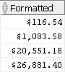

**2. Display invoice totals in scientific notation. Use the Invoices table.**

**Limit to 10 rows.**

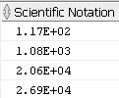

**3. Display the following result table. Use the Invoices table.**

**Limit to 10 rows.**

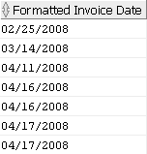

**4. Display the invoices for May 7, 2014. Use the Invoices table.**



**\*\*\*\* Use the Student table space for the following questions \*\*\*\***

**5. Display the enrollment information for students enrolling on January 30, 2007. Use the**

**Enrollment table.**

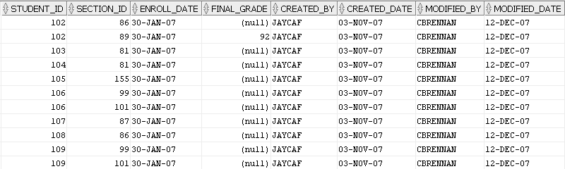

**6. Display the city, state and zip as one column. You must use the concat function to receive**

**credit. Use the Zipcode table.**

**Limit to 10 rows.**

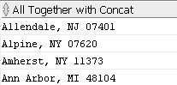

**7. Display the city, state and zip as one column. You must use ||’s to receive**

**credit. Use the Zipcode table.**

**Limit to 10 rows.**

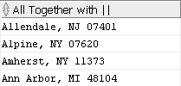

**8. Display the city in upper case, lower case and mixed case. You must use one SQL**

**statement only. Use the Zipcode table.**

**Limit to 10 rows.**

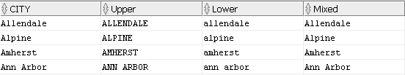

**9. Display all cities whose number of characters are between 5 and 9 inclusive. Use the**

**Zipcode table.**

**Limit to 10 rows.**

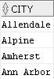

**10. Display the 2nd, 3rd and 4th character of all cities. Use the Zipcode table.**

**Limit to 10 rows.**

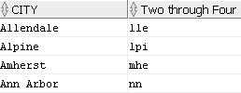

**11. Display the last 3 characters of all cities. Use the Zipcode table.**

**Limit to 10 rows.**

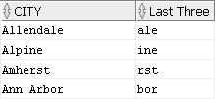

**12. Display all rows in the Grade_Summary table. For any null values in the Midterm_Grade**

**column, display 0. Use the Grade_Summary table.**

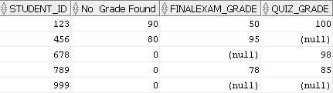

**13. Display all students that are doctors. Replace the Dr. salutation with Doctor. Use the**

**Student table.**



**14. Remove all spaces at the end of the street address. Use the Student table.**

**Limit to 10 rows.**

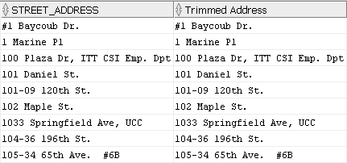

**\*\*\*\* Use the Dual table for the following questions \*\*\*\***

**15. Convert a character string to a number. Use the Dual table.**



**16. Using the SQRT function, create the following result table. Use the Dual table.**

